Construct an anemometer

Materials and equipment
- strong thread or thin fishing line — about 40 cm long
- ping-pong ball
- large protractor template
- scissors
- glue
- adhesive tape
- thick cardboard (for mounting protractor)

Method
- Use the ‘Large protractor template’. Cut the protractor out of the sheet.
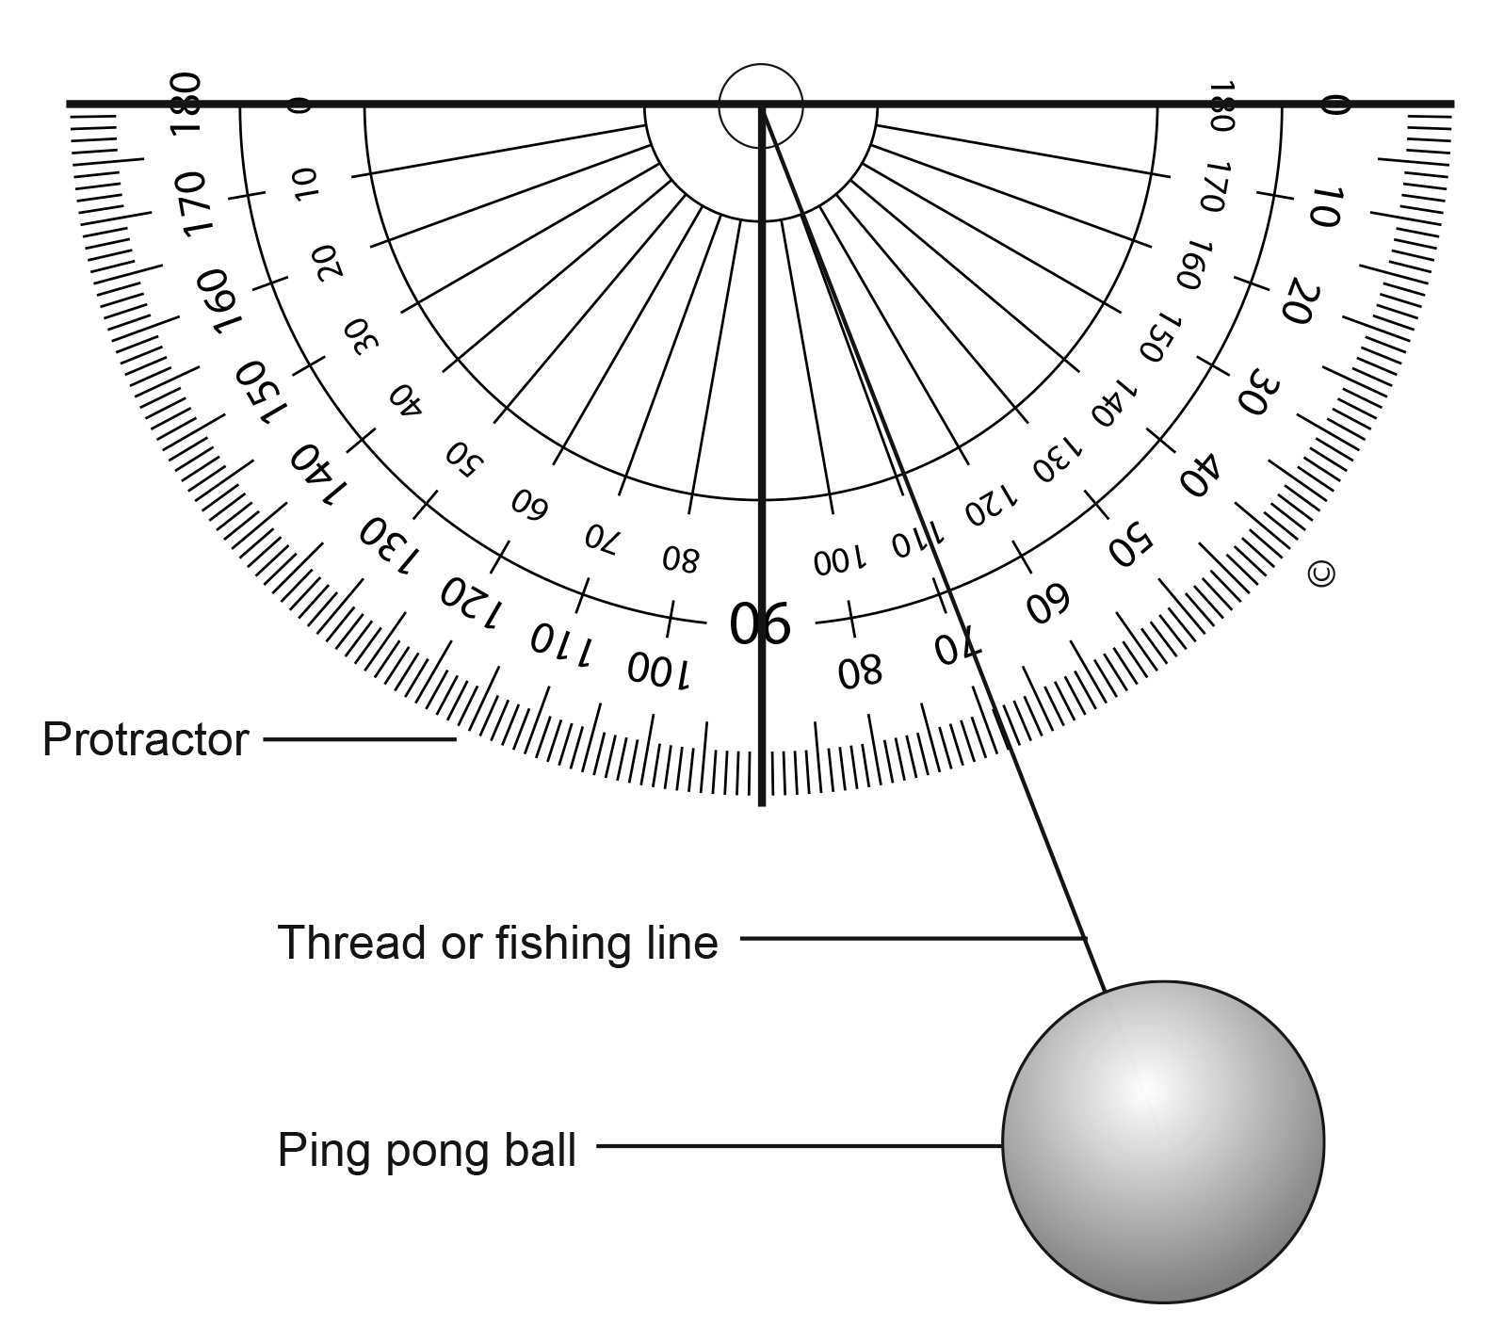
2. Stick the large protractor to the cardboard; the straight edge will be the top of the anemometer.
3. Stick one end of the string to the ping pong ball and the other end to the centre of the protractor. To attach the thread more securely, fold the loose end of the thread over the top of the protractor and tape it again.
4. Use the anemometer outside.
5. Hold the protractor horizontal to the ground. It should be held so the arc looks like a smile.
6. Check the thread with the ping pong ball is hanging straight down the centre — along the 90° line.
7. Observe the number that the string is pushed to when the wind blows the string off the centre line.
8. Use the chart below to calculate approximate wind speed.
String angle (degrees) | 90 | 80 | 70 | 60 | 50 | 40 | 30 | 20
Wind speed (km/h) | 0 | 13 | 19 | 24 | 29 | 34 | 41 | 52
9. Record your observations.
10. Repeat the observations at various times during the day for one week.
Conduct
Observations — What were your observations?

Record your observations of the movement of the string and ping pong ball.
Date/time of day | Reading (degrees) | Estimated wind speed (km/h)
Questions
- Explain how the device measures wind speed. Use your science knowledge.
- How well did the anemometer work? Can you suggest any improvements to the devise?
- How could you use this device to help inform you about the weather in your area?

Large protractor template
